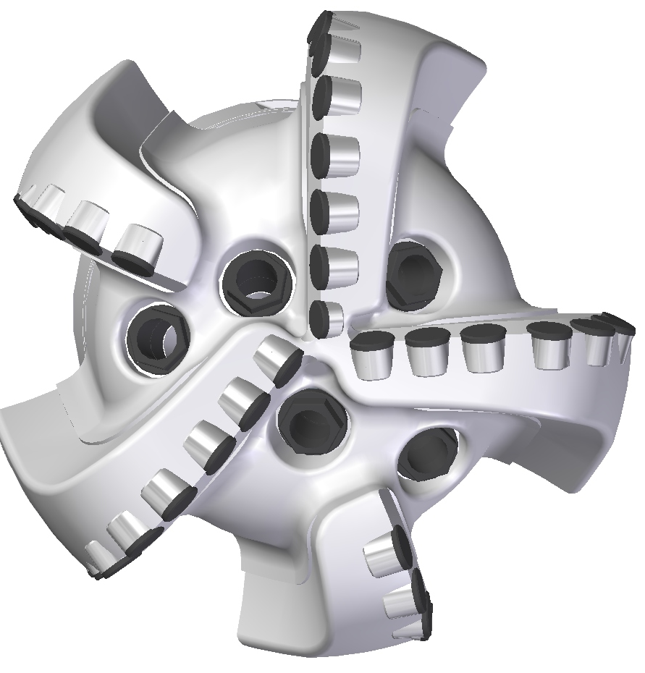 |  | 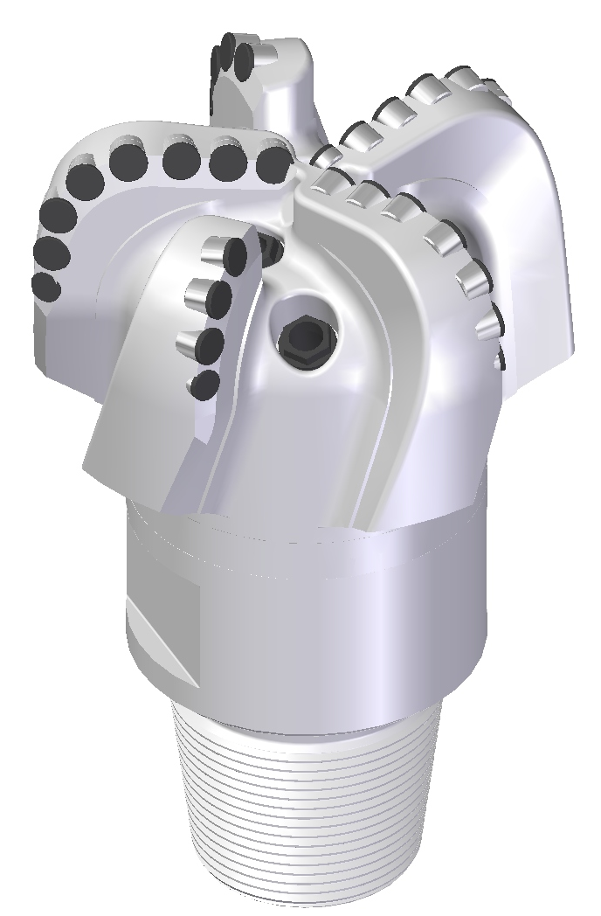

Drill Bit Specifications:
Cutter Size | 5/8" , 1/2”
Cutter Count (Total, Gage) | 32, 6
Blade Count | 5
Gage Length (Inches) | 2.00
Nozzle Count (Primary, Sec.) | 5
Nozzle Size (Primary, Sec.) | 60
JSA (Sq. Inches) | 20.41
Max. TFA (Sq. Inches) | 1.86
Operating Parameters:
Max Hydraulic Flow Rate (GPM) | 578
Max. Weight on Bit (1,000 Lbs.) | 32
Make-up Torque (ft/lbs) | 16,488
Nominal Dimensions:
Overall Length (Inches) | 13.71
Make Up Length (Inches) | 9.65
Bit Breaker | SKB-21010
Connection | Ø4-1/2" API Reg.
Approx. Weight (Lbs.) | 85

Standard Features:

- Large open face volume assists cuttings removal
- Five nozzles optimize blade cleaning and cuttings removal
- Premium grade cutters maximize ROP and life
- PDC inserts for increased gage protection

516-SR Nomenclature Explained:

• | 5 | = | Number of blades
• | 16 | = | Primary Cutter Size (16mm)
• | SR | = | Single Row of Cutters
• | 5 | = | Number of nozzles*
*Interchangeable nozzles.

